Static website hosting with s3 bucket

Firstly login to AWS console

Go to the s3 bucket

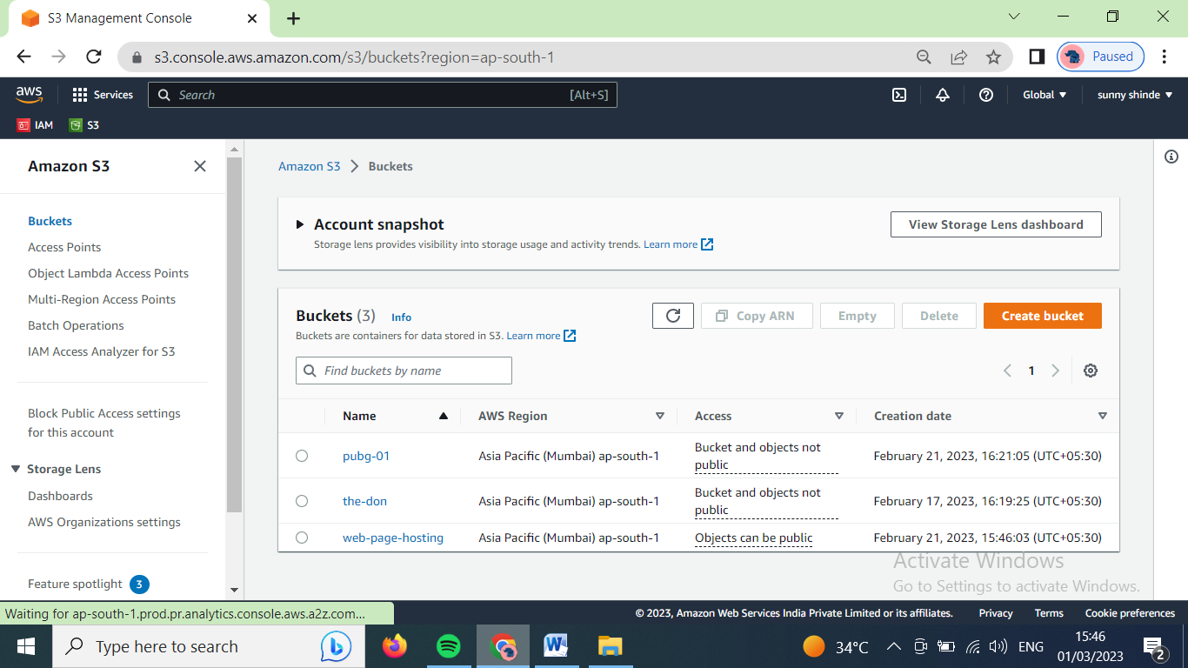

Lets create static website hosting for existing ‘web-page-hosting’ bucket as shown above.

Lets go into ‘web-page-hosting’ bucket.

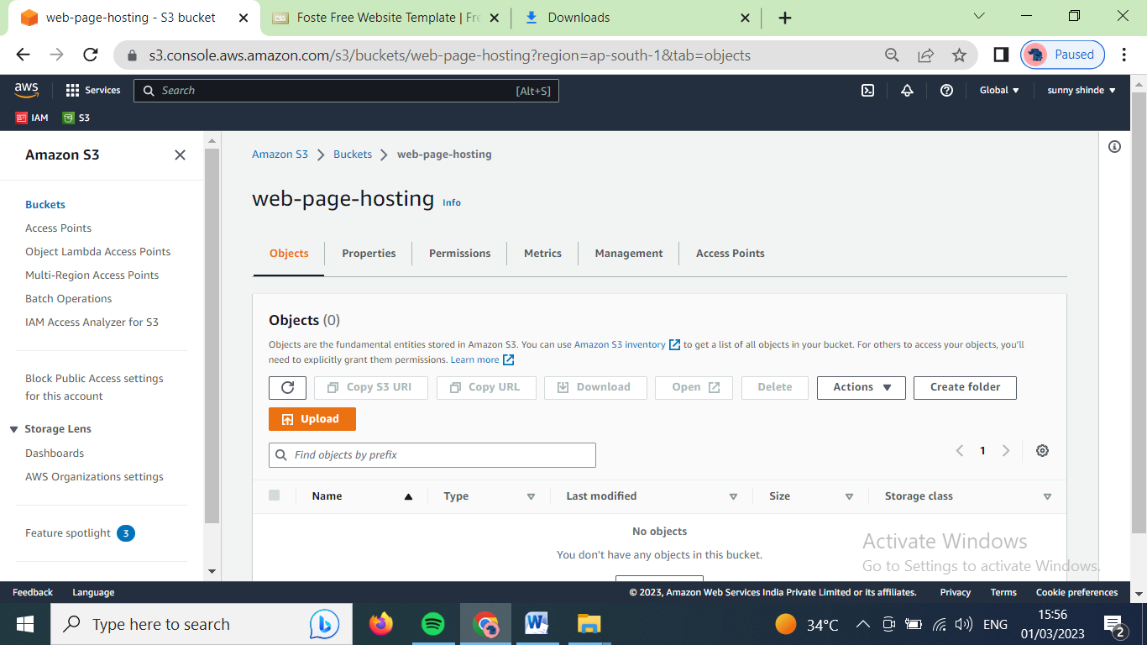

Click on upload button, the below window will open

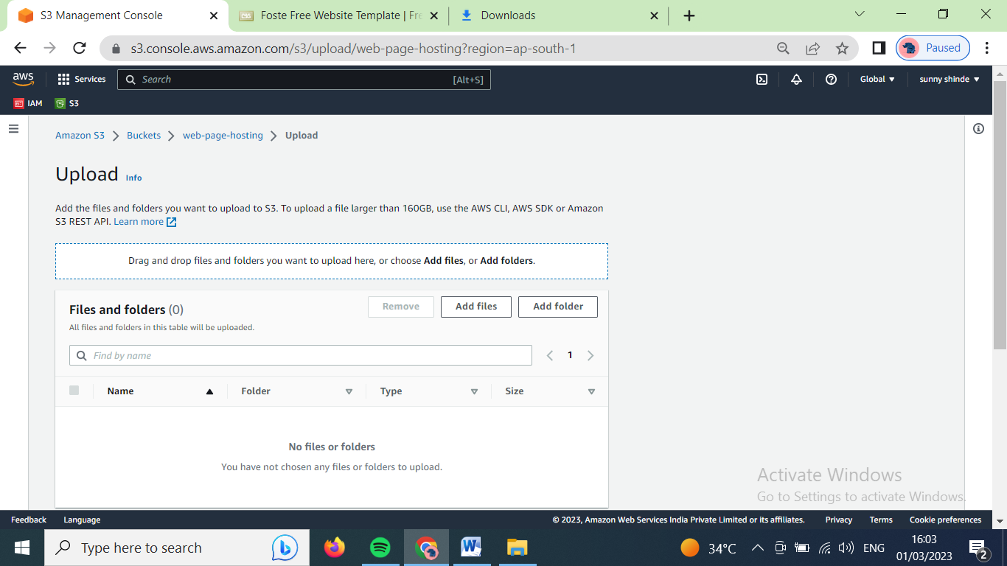

Upload the necessary files for static website hosting.

There are two ways to upload one is by selecting files for pc and second by frag and down. In below case drag and drop is used.

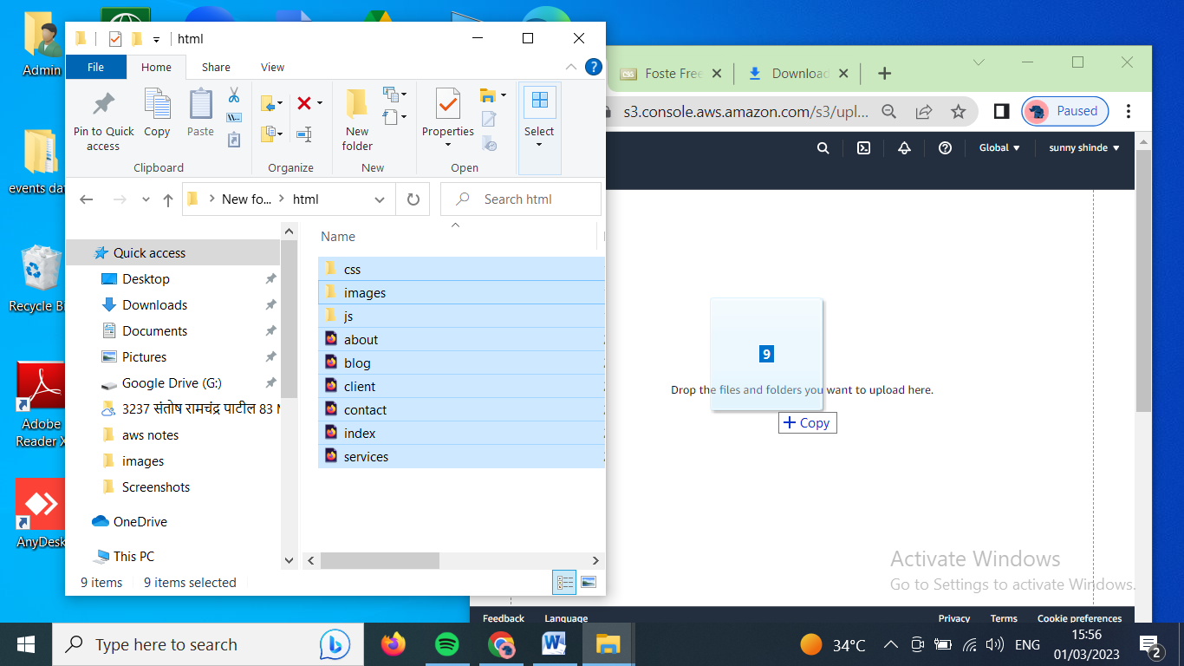

Click on upload button

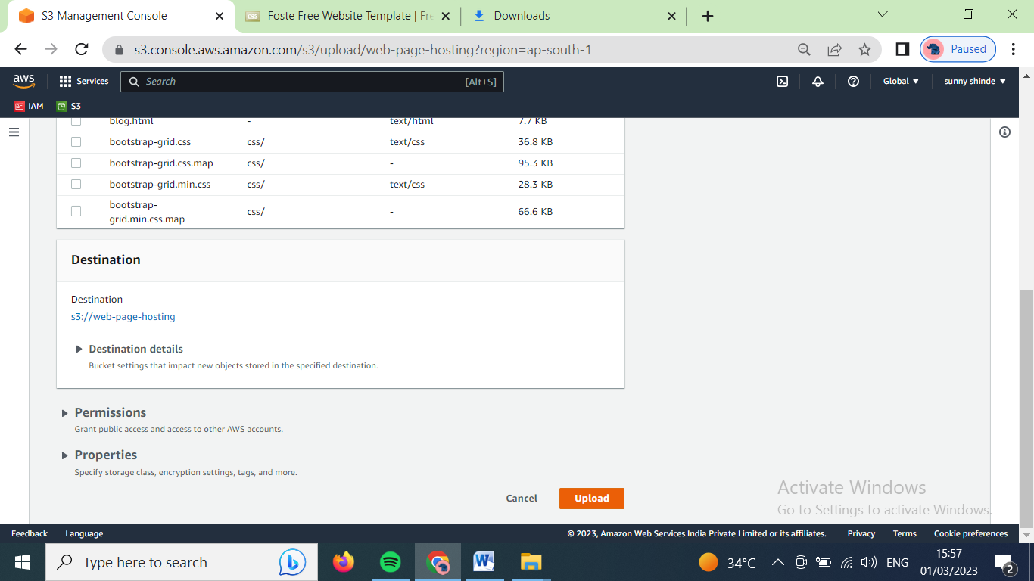

After that the below window will open

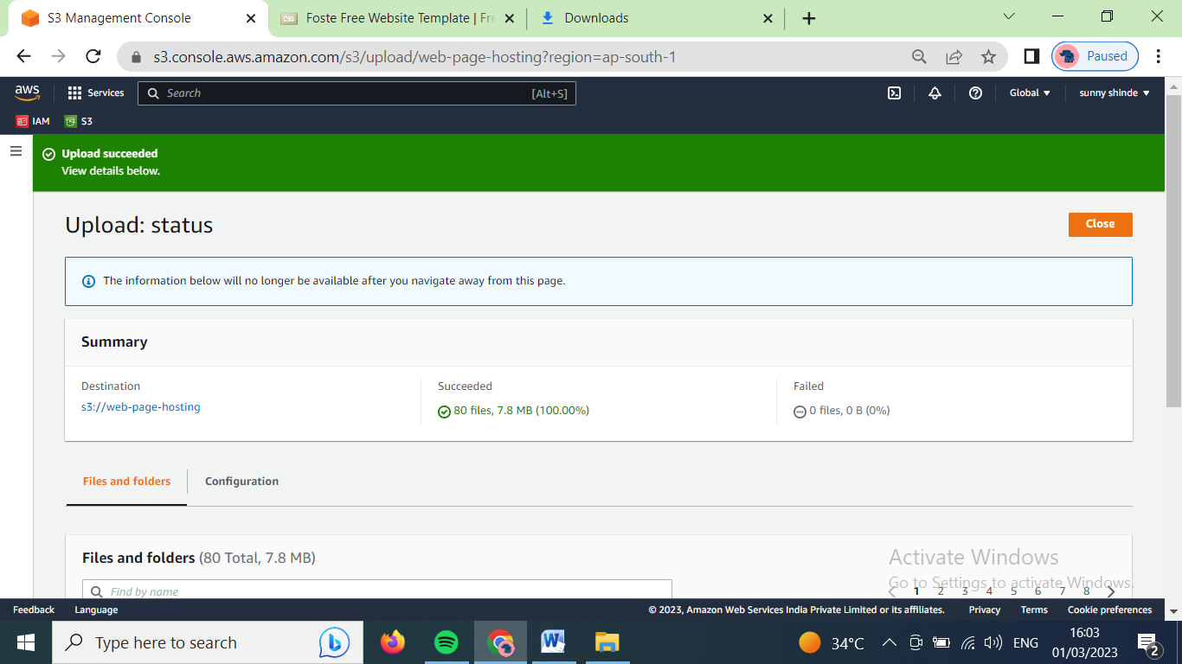

Now, our files has been uploaded. Click on close button. Our main bucket window will open (refer image no. 2). Now for website hosting our bucket and the data under it must be public. For that, in navigation bar click on permissions.

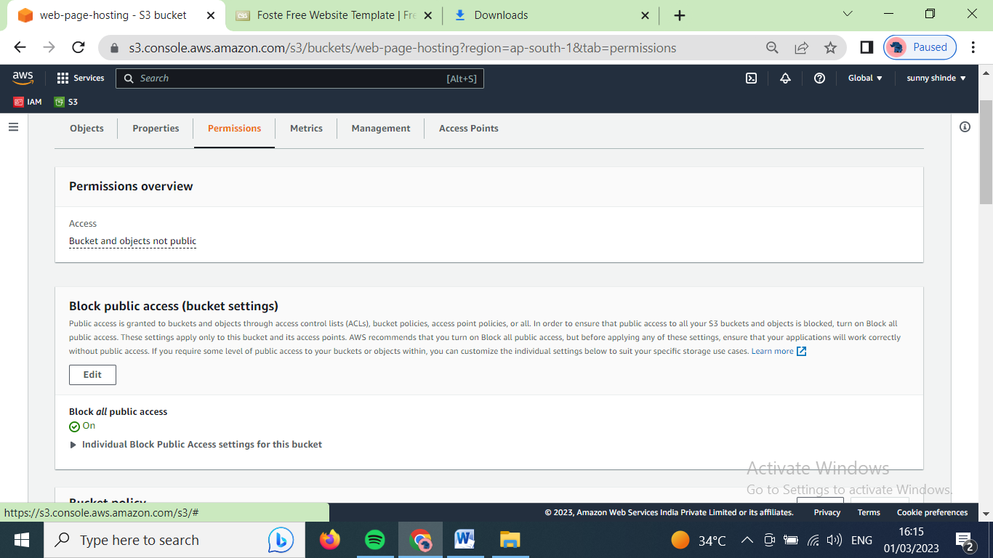

Click on edit option below the ‘block public access’ option

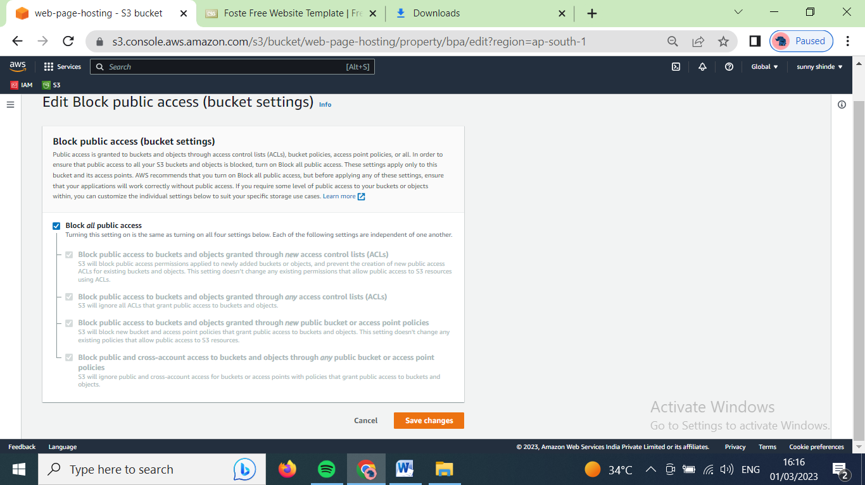

Uncheck the block public access option and click on save changes

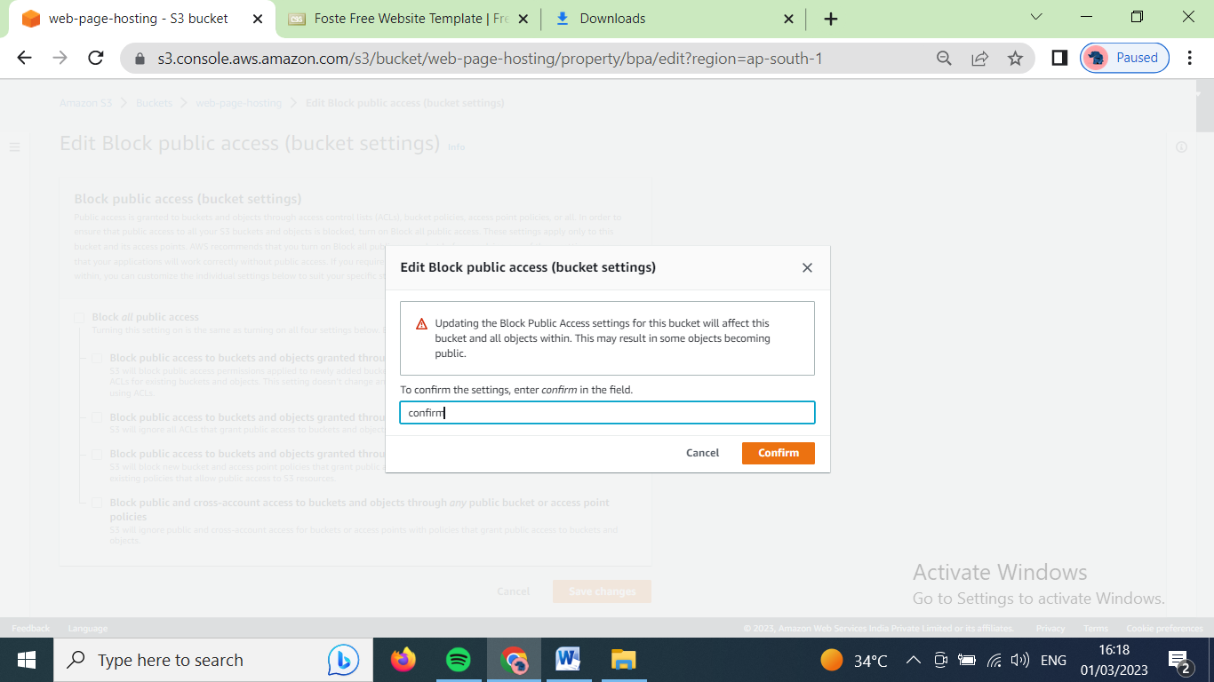

Type confirm and click on confirm button.

Scroll down

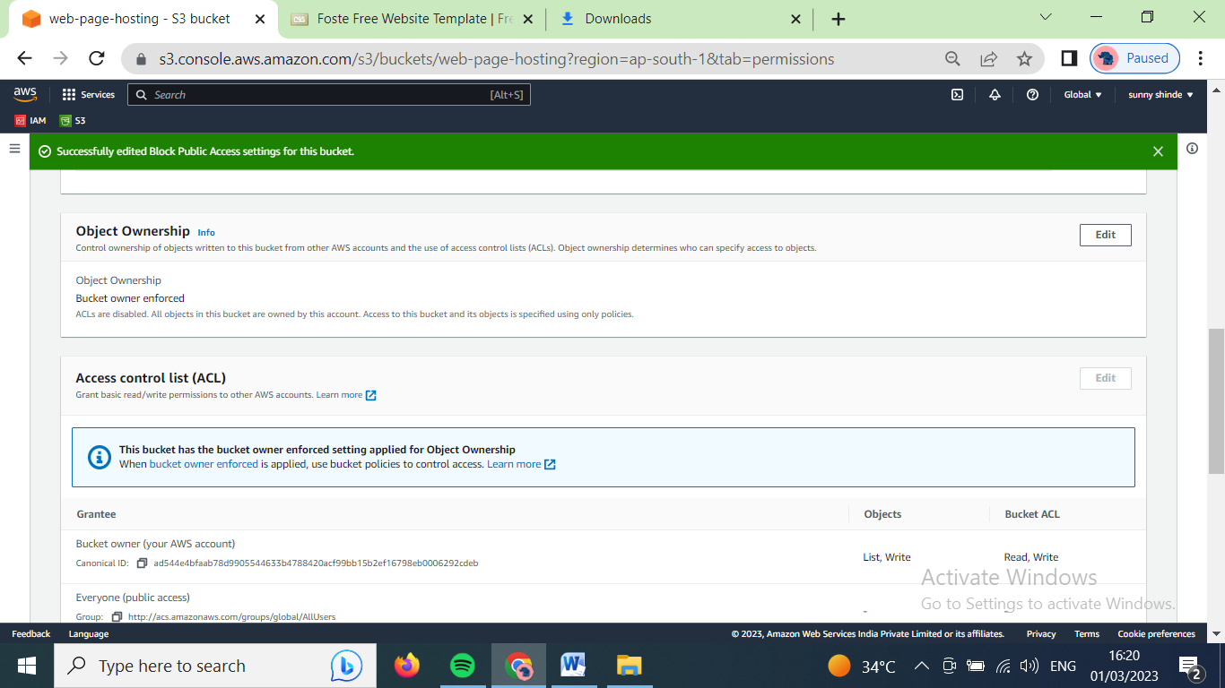

Click on ‘edit’ option on the right side of ‘object ownership’.

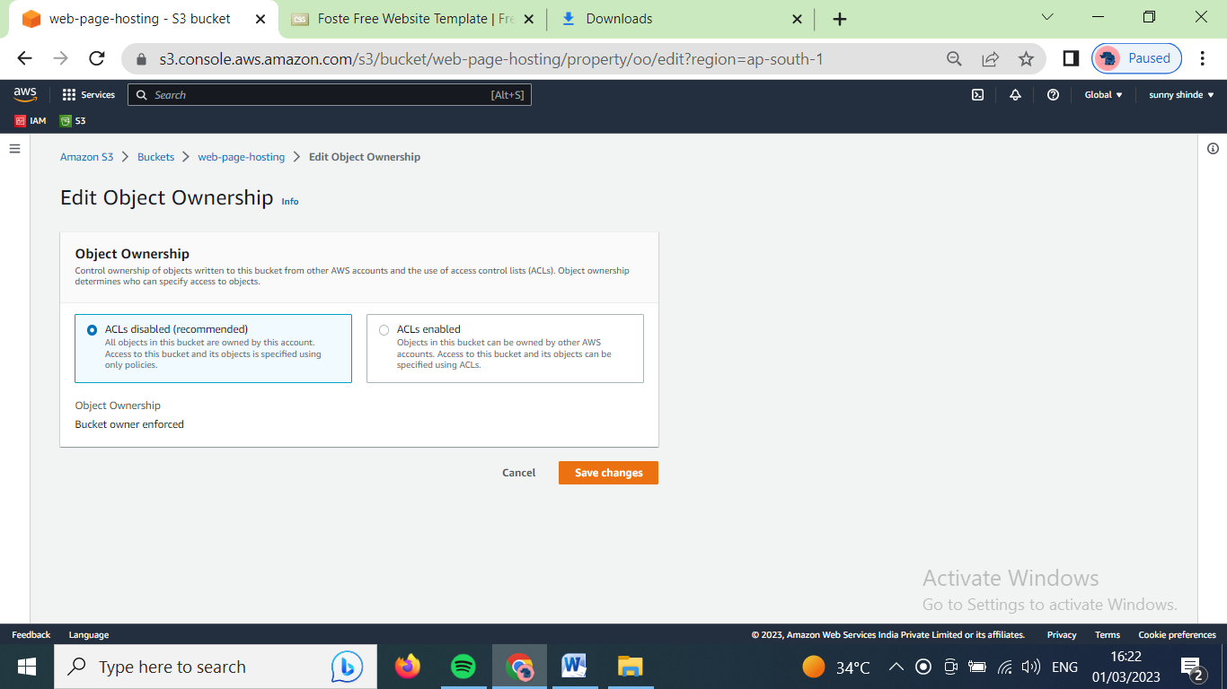

Click one ACLs enabled

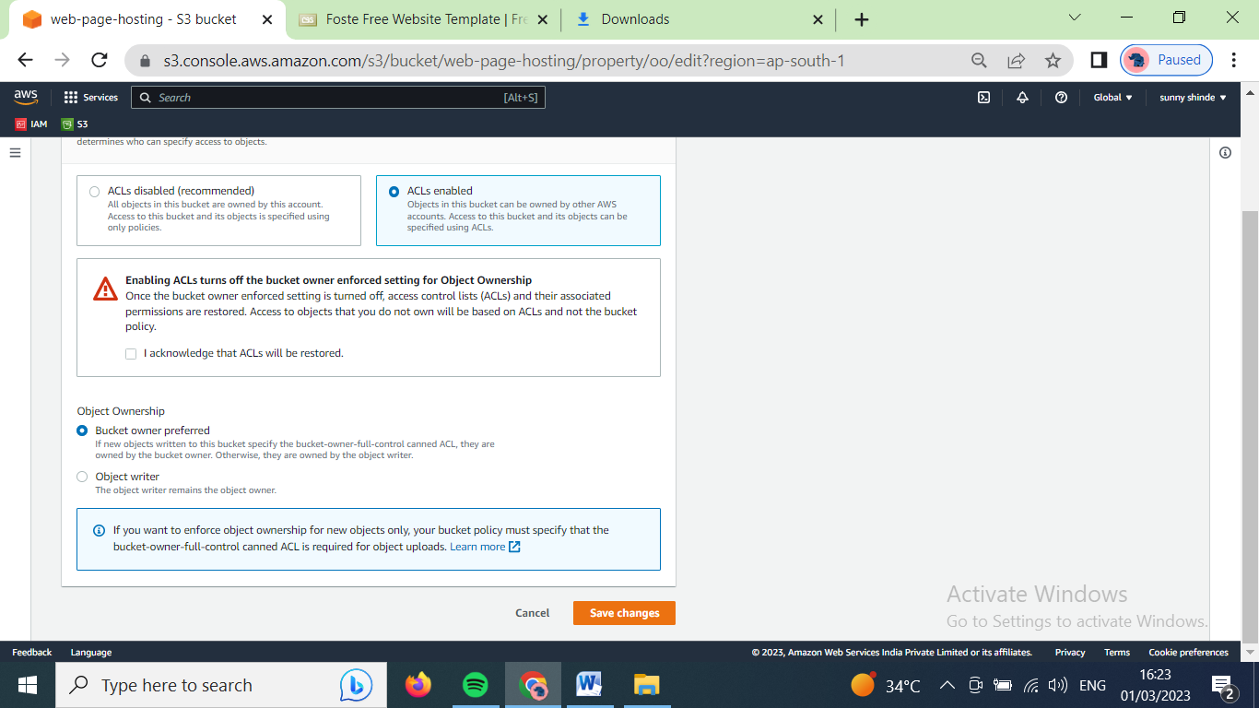

Click on checkbox of ‘I acknowledge that ACLs will be restored.’

Click on save changes.

After that on navigation bar and click on object, after that the data inside the bucket will show.

Select all the files and click on action 🡪make public using ACL

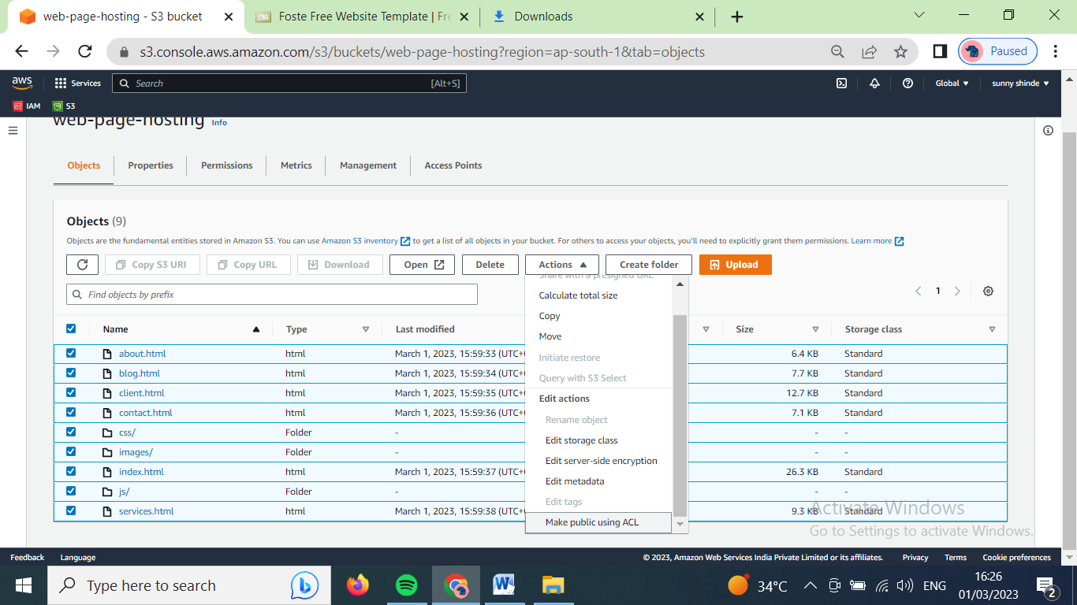

The the following window will open.

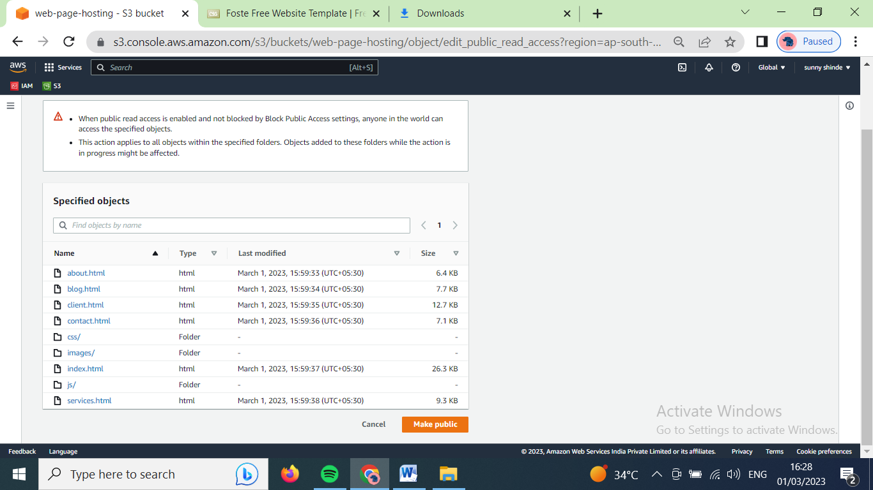

Click on make public, the the following window will open

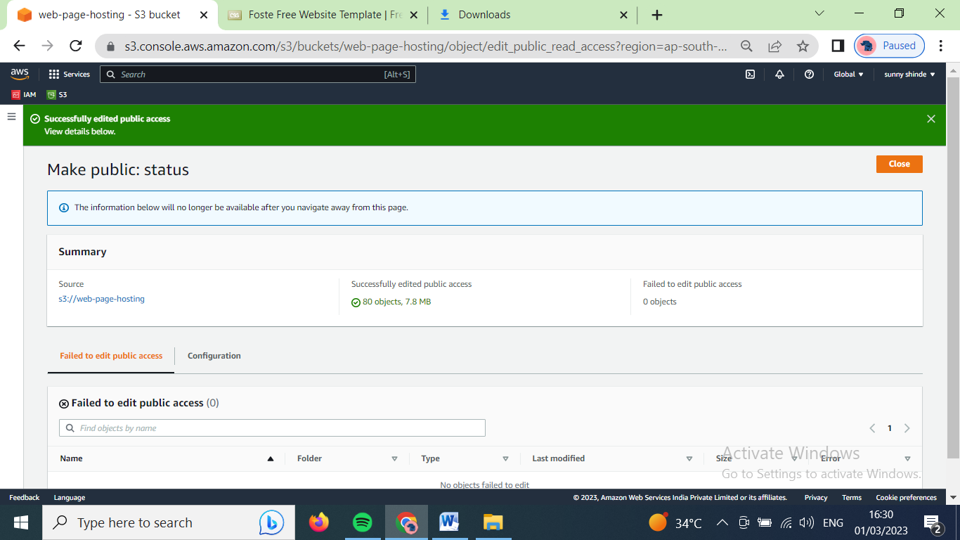

Click on close.

Now, on navigation bar click on properties

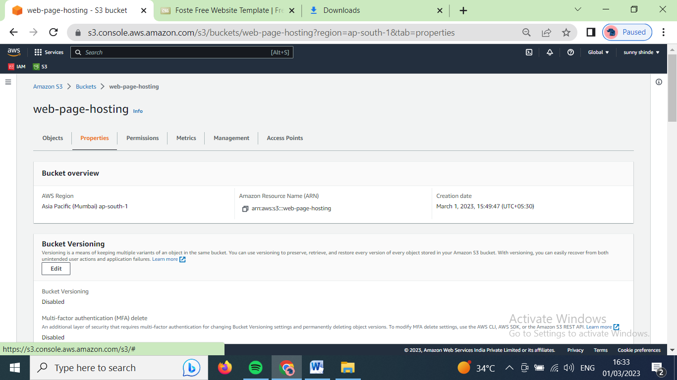

scroll down to bottom

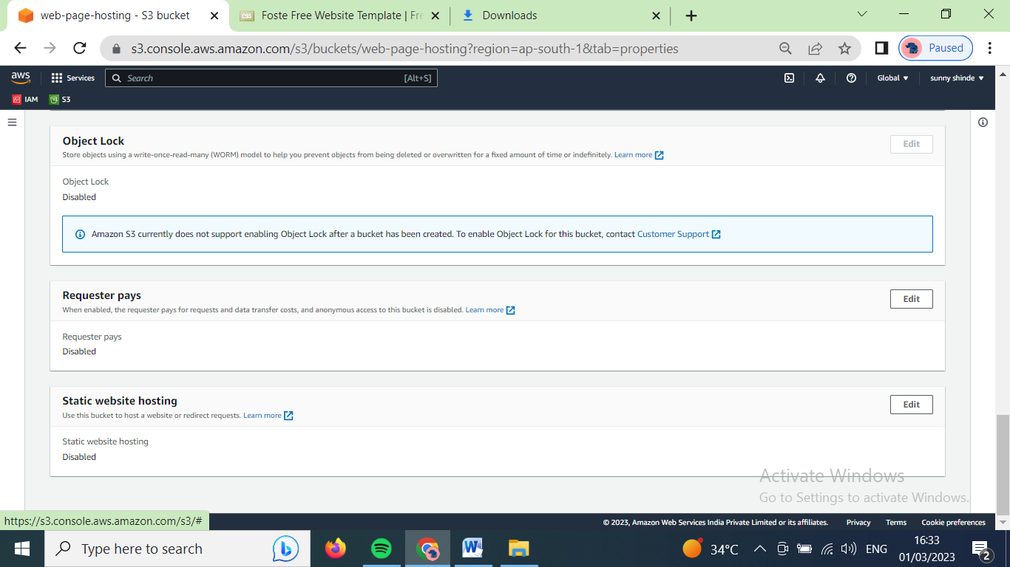

Click on edit button, placed on right side of ‘static website hosting’.

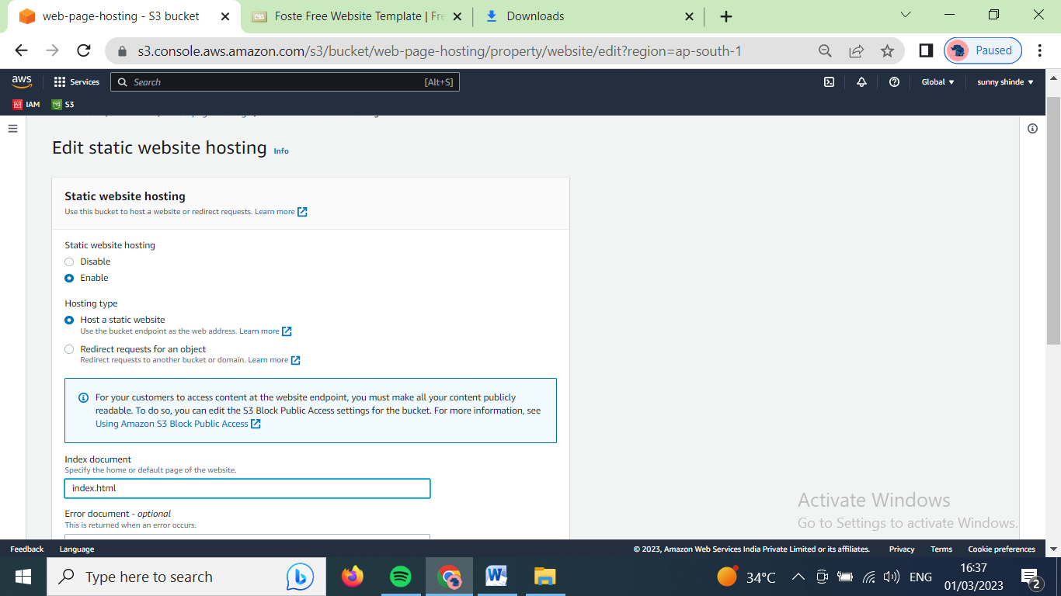

Choose ‘enable’ for static website hosting option.

Choose ‘host a static website’ for hosting type.

Type ‘index.html’ in Index document box.

Scroll down and click on save changes button.

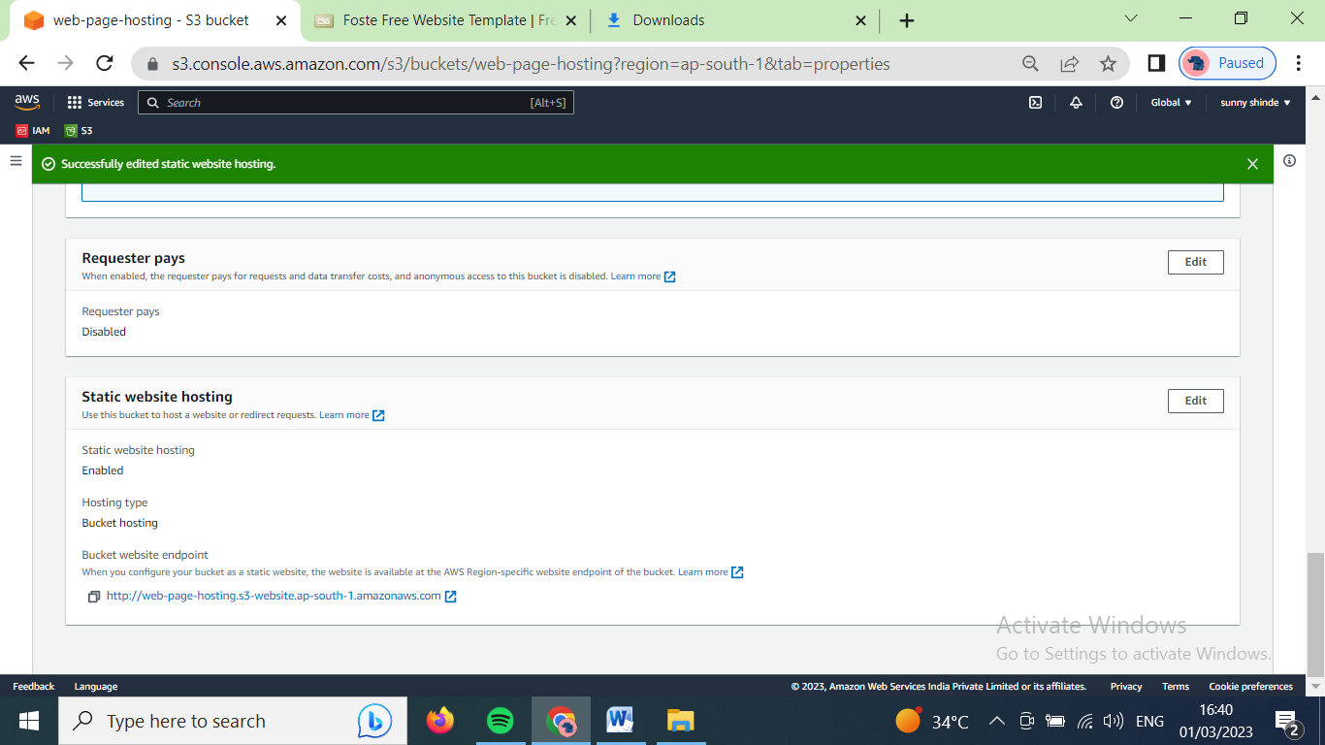

Copy the link for static website hosting. And paste it in another tab.

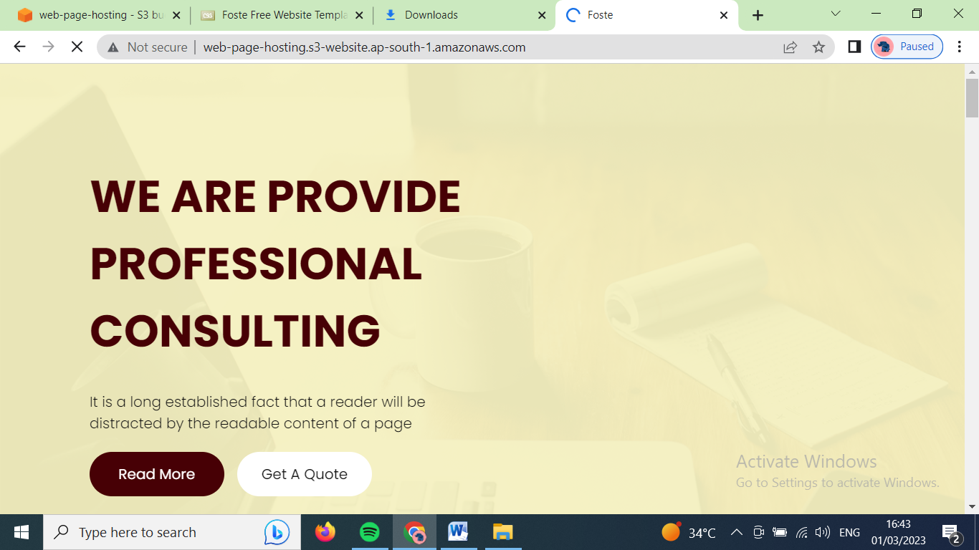

Now, our website has been hosted.